*Topics covered –*

* PDF conversion using ms word object
* Windows Automation - calculator , 1+2=3 , parametrized in object studio

*Things to practice -*

*Important points*

Application Modeller for windows based apps

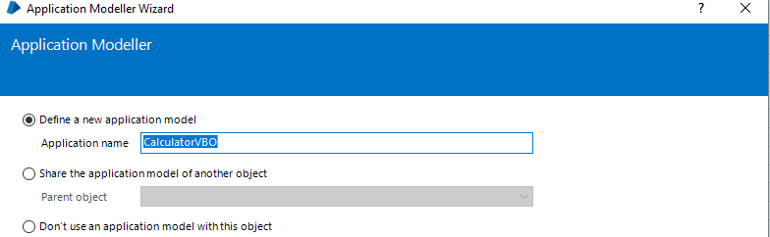

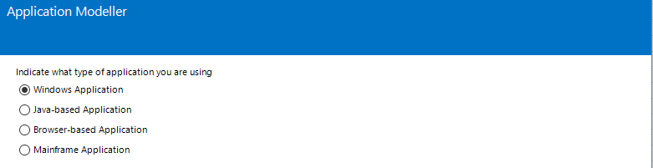

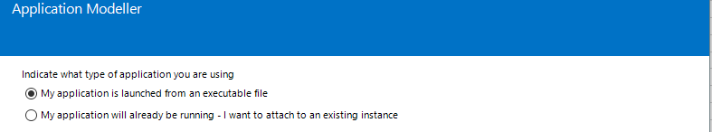

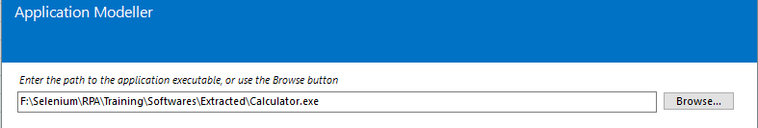

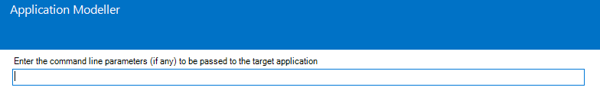

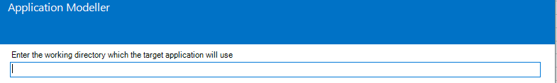

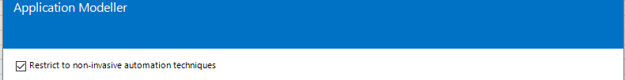

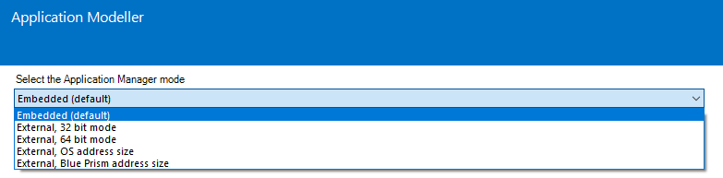

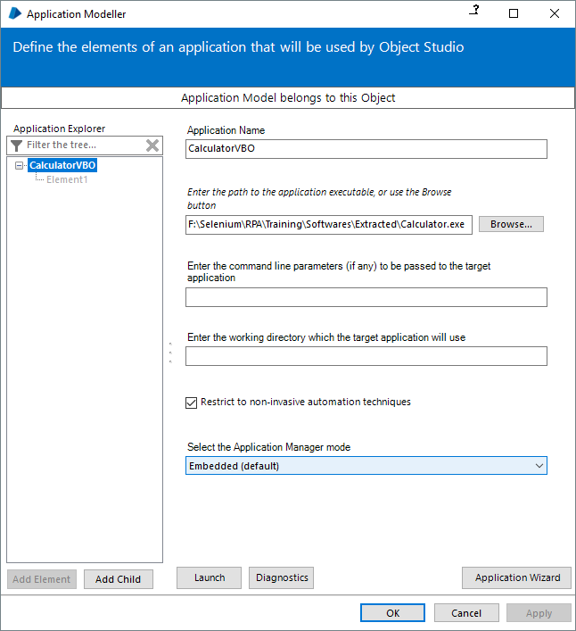

Pending:- Explore all above options

In the object studio, drag and drop the Navigate stage, Add element under Actions Tab. Drag and Drop CalculatorVBO(head) onto Element column in the RHS

Pending:- Explore all Actions that can be performed at application level

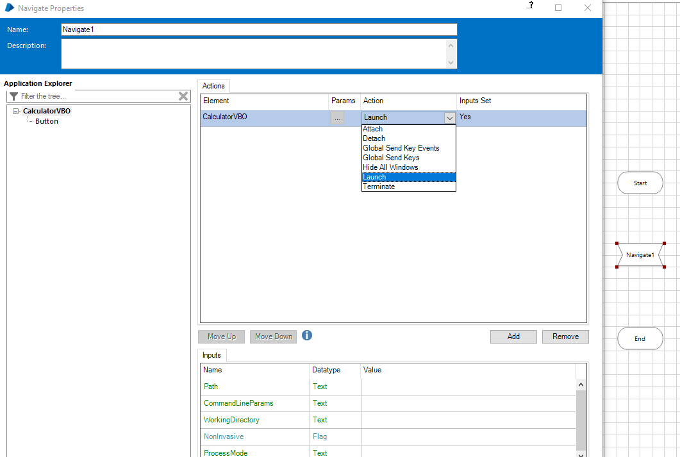

Click Add Child to add first element inside the application modeller

After selecting an element using win-32 mode, do a control-click on the element you want to extract

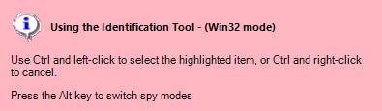

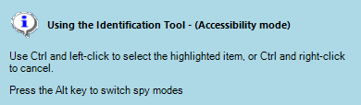

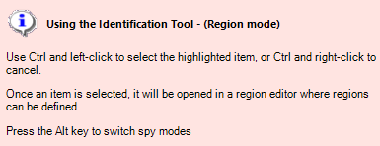

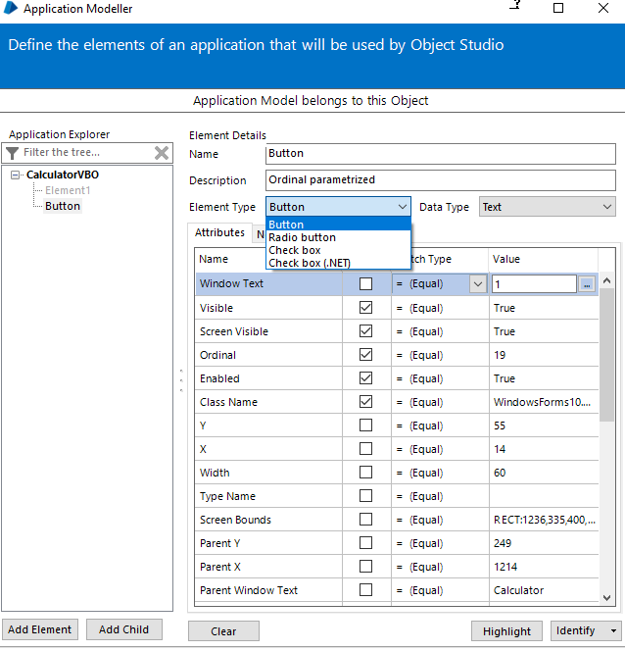

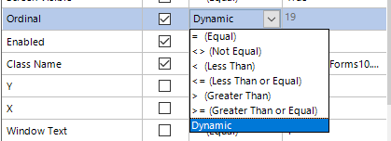

To parameterize a property, set its **Match Type** to dynamic, its **Value** will be greyed out

When we extract text box into application modeller

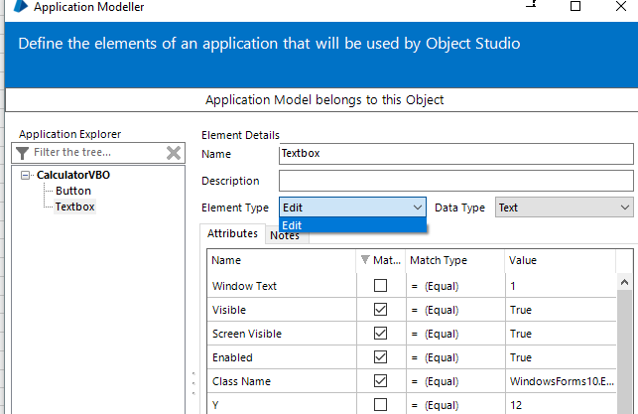

Remember the option which are used to match for windows elements

Single row ticked

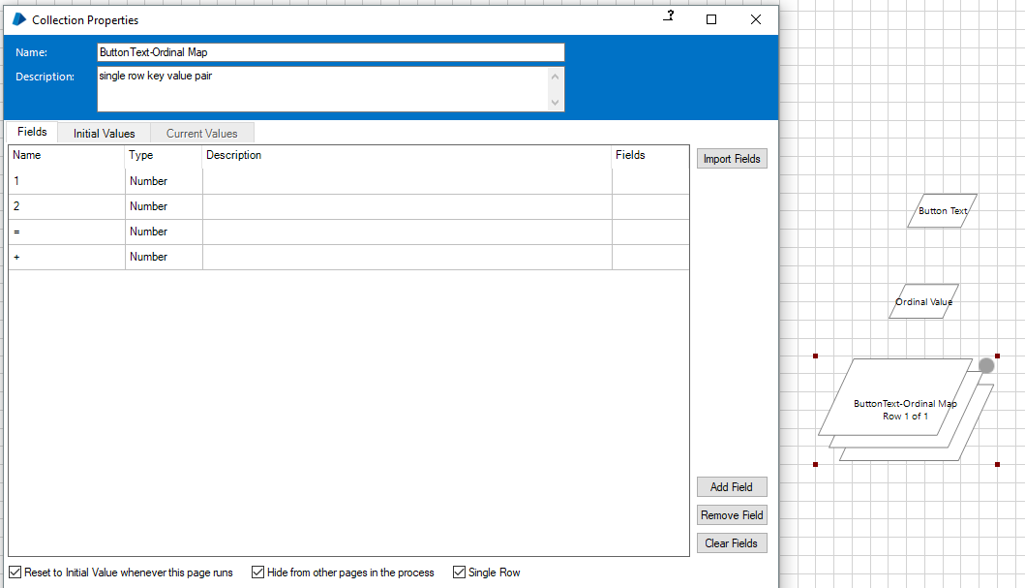

Add a navigate stage – drag drop button element that is to be clicked the button with parameters

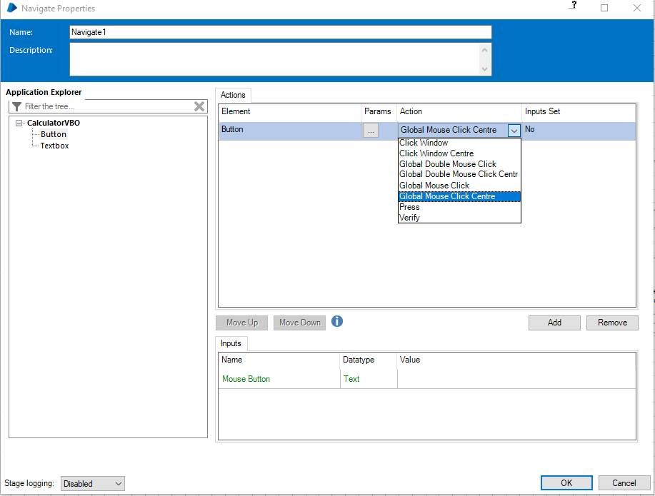

Pending :- Explore All Options Above

Add an action stage to Read data from a single row collection (Note that both Field Name and Outputs have to be of text datatype) from imported VBO (BPA Object - Utility - Collection Manipulation.xml)

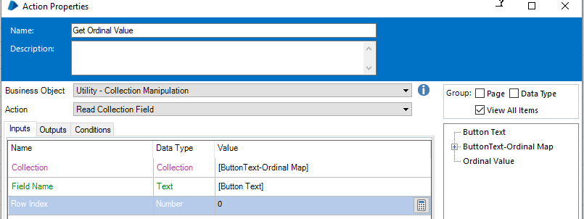

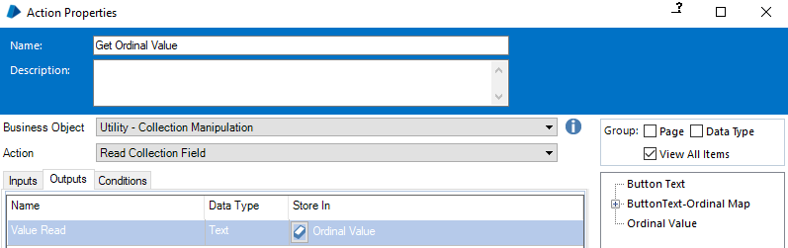

In the process studio, add an action object, select calculator VBO and click button action, it will automatically ask for inputs under the input tab

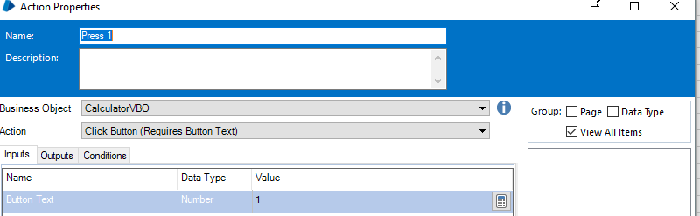

Read Stage

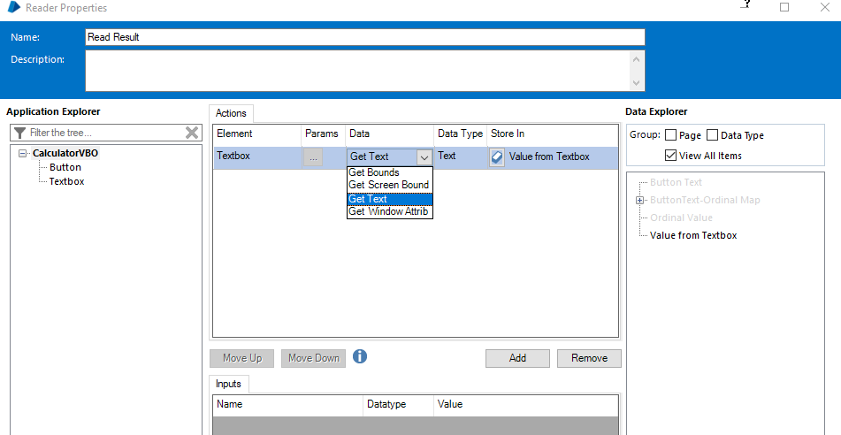

**Other notes**

multiple pages in process so that we can segregate functionality if it becomes too big, for eg - excel-grading system demo

-we can select multiple items n do a cut

-do grading system demo in pages(modularzation)/ screenshot of new page stage

-PDF -- MS Wod VBO -- number handle CREATE_INSTANCE() -- text documentName OPEN(handle,FileName) -- void EXPORT_PDF(documentName,handle,FileName)

-twilio

-process options vs page options -- options in object studio differ from process studio - read,write,navigate,code,wait

-oracle virtual box for testing calculator app in windows 7

-F1 for help - read through all the stages

--attach screenshot of Action Popup, to get familiar with options

-we configure all the elements with Application Modeller, link all the functionality of application modeller in different stages of object studio, call these pages from the process studio

-do application modeller - new exe/browser which is already running (attach usage - pop up that comes when we try to do mstsc, that pop up doesnt have executable file)

- Action dropdown values for an element |Element|Params|Action|Input Set|

-global mouse click(X,Y,Mouse Button) vs global mouse click centre(Mouse Button)

- start/end properties of calculator object page (to pass to next page)

|Name|Datatype|Description|Store In|

corresponding action property

|Name|Datatype|Value|

- additonal windows example using the training order system- involves exception handling